- Created a private instance (us-central-1 region ) with only private ip. I.e there is no external ip.

- While creating instance itself , assigned the network tags ( http trigger , https ) so that the traffic is ingressed from http web server.

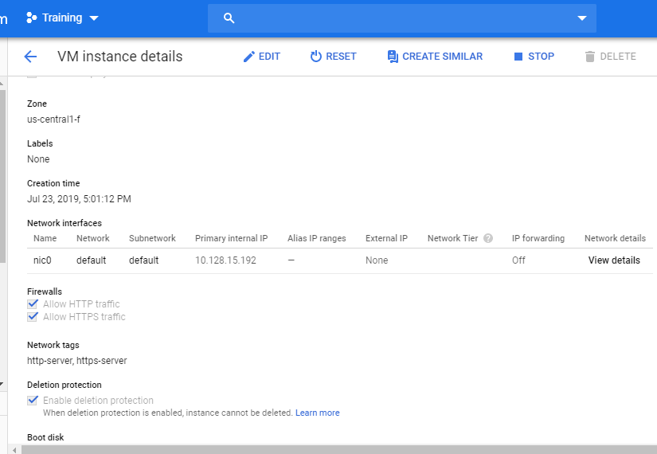

- we can’t open ssh terminal for an instance which have only internal ip. So , we have created one public subnet since it has an external ip.

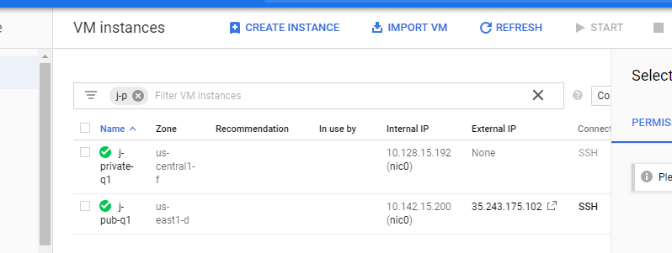

- Using external ip, connected to ssh terminal

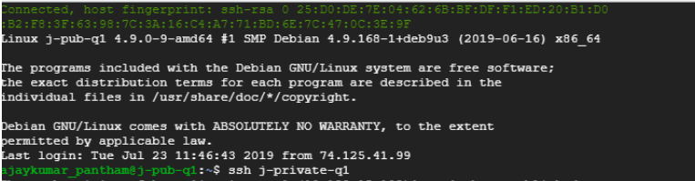

- later got connected to private instance from the ssh of public instance
By running the command

Ssh j-private-q1

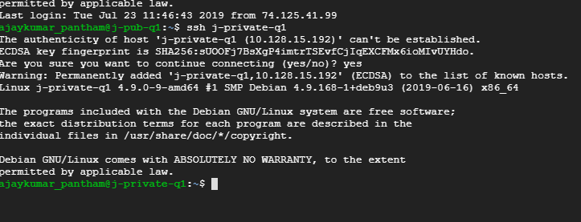

- A private instance can’t access access internet directly so a NAT gateway is created in a region where private instance is there.

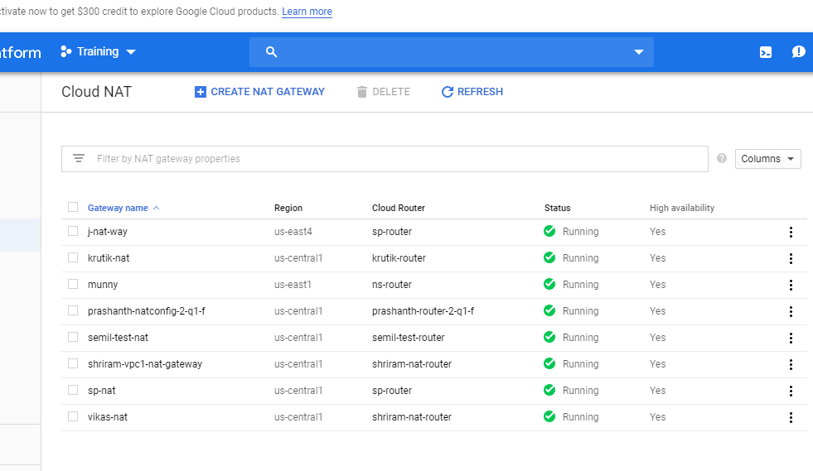

- It is associated with the VPC network of the two instances.

- Only one NAT gateway can be created for each region for a vpc network.

- From the private instance pinged the server with ip address 8.8.8.8 which is google DNS server

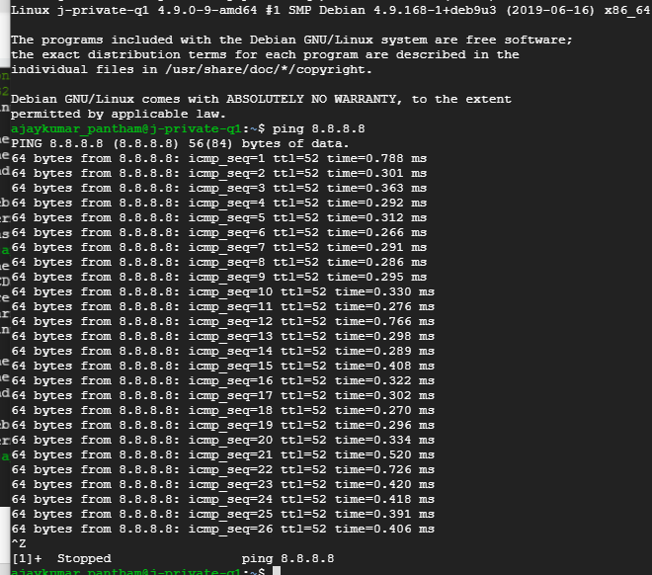

- We received the response from internet ( google) in amount bytes of data which

means that our private instance has accessed the internet using the NAT gateway

